BWSRC Board Meeting Minutes
8/14/2016 @ 6:00 PM
Location – Pool

- Roll Call
Present: Chriss Carsello, Joan Schrum, Lisa Schumacher, Mitch Geers, Becky Bolsinger, Brandy Feldman, Mark Denny, Michael Bauer, Tawnya Stone, Tiffany Chamberlain, Sarah Hora, Eric Shepley

Absent: Kristi Whitham, Tom Neff

- Board Member Updates

Treasurer: Bank balances: Bank Iowa: $26,474.77. Community Savings Bank: $47,231.08 (checking), $54,025.64 (savings). Total $127,731.49

Membership: There are 29 families on the inbound and 20 on the outbound waiting lists.
Secretary: We want to rent PODS to store our new chairs and umbrellas. Here is pricing for a 16x8x8 POD.
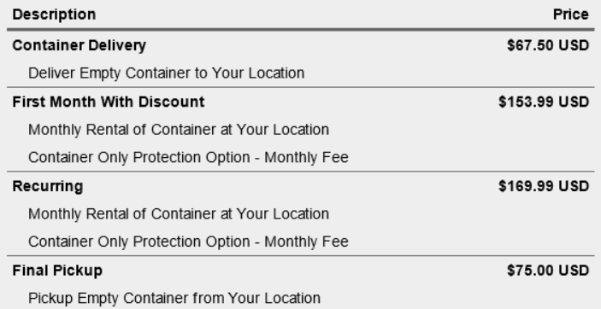
Tennis Team: We had over 40 kids play in this year in the tennis tourney. All went well. Good year. Tennis team went 3-3 on the year, had approx. 25 team members. Held practices daily at Linn-Mar, able to use 6 hard courts and allow more court time for team members. Held a free tournament August 5th. 35 entries, many played in their first tournament. Trophies awarded for singles and doubles champions and runner-ups in four different age categories. Also had a consolation bracket for those who lost their first match. Lots of parents/grandparents/families attended to watch.
Webmaster: Sarah has the website trials narrowed down to these 2 options: http://www.wildapricot.com/ and http://www.clubexpress.com/. After school starts we will start the 30 day free membership trial to test them out and see which one is better for our club. Request that Becky with Membership and Kristi/Brandy the Treasurers to have a look at it during the free trial phase and see which has better software for account and finance management. If anyone else would like to have a closer look during the trial phase please do. She will notify everyone once the free membership trial has started.

- New business
- Linn-mar Girls Swimming asked for a $100 donation to their poster and will include BWSRC logo on the poster. Motion to contribute, passed.
- The pool hours will be reduced starting Tuesday, August 23rd…announcement needs to be made through the various channels (Facebook, Twitter, Website, Email Blast, etc). Weekdays 4:30PM - 8:30PM.
- Mitch will not be returning as pool manager. Need to start looking for someone that is willing be certified. BWSRC would pay for certification.
- Ultra-Lawn hasn’t been doing a very good job…need to talk to them.
- Renovation options to be investigated. No pricing yet. Will work with DJ Pools and put some options together. Ideally we have a plan for this year, will implement the following year after the pool closes.
  - Re-surface the entire pool. Seal deck and coping. Structure of the pool is solid. Would extend the life of the pool.
  - Eliminate kiddie pool and make zero entry. Can’t do anything that would cause water to backup. If not extending the deck, shouldn’t be an issue.
- The following board member positions will be available at the Annual meeting:
  - President
  - Co-Treasurer (1)
  - Swim Team
  - Pool and Grounds
  - Social (2)
- Informal social planned for 9/3 @ 8:30. BYOB.
- Clean-Up day will be Saturday, 9/18 @ 10AM.

Next meeting: Sunday, September 18th 9:30AM (at the pool), Clean-Up to follow @ 10:00AM

